**BANKING NETWORK SYSTEM**

**BY:**

MWESIGWA CHRISTOPHER

**INTRODUCTION**

This is a banking network system. This project is intended for any banking company that wishes to expand its services to a new area. The project is based on a four-floor storage building. I decided to exercise my knowledge in modeling and designing this banking company network based on the requirements that i assumed to meet any banking company's needs.

**TOOLS USED**

Microsoft Vision: this software tool was used to model and visualize the topology for the network.

Cisco Packet Tracer: this software tool was used for network design and implementation.

Laptop: this hardware tool was used for installing and running the software tools.

**REQUIREMENTS**

the assumed requirements are as below;

Each floor has a department with devices as allocated in the table below

|  |  |  |  |  |
| --- | --- | --- | --- | --- |
| **FLOOR** | **DEPARTMENT** | **PCs** | **PRINTERS** | **SERVER** |
| **FISRT FLOOR** | Management | 20 | 4 |  |
| Research | 20 | 4 |  |
| Human Resource | 20 | 4 |  |
| **SECOND FLOOR** | Marketing | 20 | 4 |  |
| Accounting | 20 | 4 |  |
| Finance | 20 | 4 |  |
| **THRID FLOOR** | Logistics | 20 | 4 |  |
| Customer care | 20 | 4 |  |
| Guests | 20 | 4 |  |
| **FOURTH FLOOR** | Administration | 20 | 4 |  |
| ICT | 20 | 4 |  |
| Server room | 2 | 4 | 3 |

**The following requirements were also considered;**

* Each department is provided with a wireless connection for users except the server room.
* Host devices in the network are expected to automatically obtain IPv4 addresses from the dedicated DHCP server in the server room.
* Devices in the network are expected to communicate with each other.
* HTTP and Email servers are located for future expansion.
* SSH is configured in all routers for remote login.
* Hierarchical network design with redundancy is used: having core, distribution and access layer.
* Each department is having a different VLAN with a different subnet.
* The base IP address is 192.168.10.0 for other devices and 10.10.10.0 for routers.
* Port security is configured with sticky mac address and violation: shutdown.
* Devices in same and different VLAN are supposed to communicate.

**IP ADDRESSING**

Subnetting was done and IP addresses allocated to the networks and hosts as in the tables below;

**Base network address: 192.168.10.0/24**

|  |  |  |  |
| --- | --- | --- | --- |
| **FLOOR** | **DEPARTMENT** | **NETWORK ADDRESS** | **SUBNET MASK** |
| **1ST FLOOR** | Management | 192.168.10.0 | 255.255.255.192/26 |
| Research | 192.168.10.64 | 255.255.255.192/26 |
| Human Resource | 192.168.10.128 | 255.255.255.192/26 |
| **2ND FLOOR** | Marketing | 192.168.10.192 | 255.255.255.192/26 |
| Accounting | 192.168.11.0 | 255.255.255.192/26 |
| Finance | 192.168.11.64 | 255.255.255.192/26 |
| **3RD FLOOR** | Logistics | 192.168.11.128 | 255.255.255.192/26 |
| Customer | 192.168.11.192 | 255.255.255.192/26 |
| Guest | 192.168.12.0 | 255.255.255.192/26 |
| **4TH FLOOR** | Administration | 192.168.12.64 | 255.255.255.192/26 |
| ICT | 192.168.12.128 | 255.255.255.192/26 |
| Server room | 192.168.12.192 | 255.255.255.192/26 |

**Base network address: 10.10.10.0/24**

|  |  |  |
| --- | --- | --- |
| **NO.** | **NETWORK ADDRESS** | **SUBNET MASK** |
| 1 | 10.10.10.0 | 255.255.255.252 |
| 2 | 10.10.10.4 | 255.255.255.252 |
| 3 | 10.10.10.8 | 255.255.255.252 |
| 4 | 10.10.10.12 | 255.255.255.252 |
| 5 | 10.10.10.26 | 255.255.255.252 |
| 6 | 10.10.10.20 | 255.255.255.252 |
| 7 | 10.10.10.24 | 255.255.255.252 |
| 8 | 10.10.10.28 | 255.255.255.252 |
| 9 | 10.10.10.32 | 255.255.255.252 |
| 10 | 10.10.10.36 | 255.255.255.252 |
| 11 | 10.10.10.40 | 255.255.255.252 |
| 12 | 10.10.10.44 | 255.255.255.252 |
| 13 | 10.10.10.48 | 255.255.255.252 |
| 14 | 10.10.10.52 | 255.255.255.252 |

**CONFIGURATION STEPS**

The network devices were configured as below

1. Basic configuration to all devices including ssh on routers and layer 3 switches.
2. Assignment of VLANS and allocation of access and trunk ports.
3. Configuration of switch port security to all layer two switches
4. Subnetting and IP addressing
5. Configuration of OSPF routing protocol on routers and layer 3 switches
6. Allocation of static IP address to DHCP server
7. Inter-VLAN routing on the layer 3 switches including IP DHCP helper addresses
8. Wireless network configurations.
9. Verification of the network connections.

**NETWORK DESIGN MODEL**

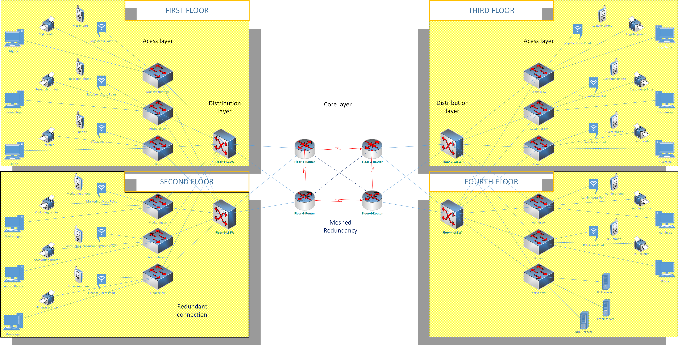

**Logical Topology**

